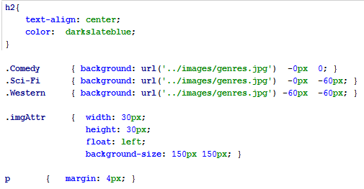

/stylesheets/pug.css

***//  
 Created by Edge Tech Academy on 6/22/2017.  
 Pug syntax styles - this one right here is a multi-line comment  
// MIXINs are macros/functions to be used***

***usually in iterating over a list*****mixin** showGenre(***genre***)  
 **div**(**class**=***genre*** + **' imgAttr'**)  
 **p**.*genre*= ***genre* br**- **var *movieTitle*** = **'Pug: The Movie!'**- **var *title*** = **'Fun with Pug!'  
  
doctype html  
html  
 head  
 title**= ***title* link**(**rel**=**'stylesheet'**, **href**=**'/stylesheets/pug.css'**)  
  
 **style**.  
 **p**.**genre** { **color**: **#86aa16**; }  
  
- **var *classes*** = [**'firstClass'**, **'highClass'**, **'noClass'**];  
- **var *genres*** = [**'Comedy'**, **'Sci-Fi'**, **'Western'**], ***genres0*** = [];  
- **var *youAreUsingPug*** = **true**;  
  
**script**(**type**=**'text/javascript'**).  
 **var *findArea*** = **true**;  
 **if** (***findArea***)  
 *area*(5);  
 **function** *area* (radius) {  
 ***console***.log(**"The Circle has an area of: "** + **Math**.**PI** * **Math**.pow(radius, 2));  
 }  
  
**body  
 h2 What should we see tonight? #[em #{*movieTitle*}] Of course!  
 img**.*imgClass*(**src**=**"/images/pug.png"**)  
  
 - **var *authenticated*** = **true  
 #container**(**class**=***authenticated*** ? **'signedIn'** : **'anon'**)  
 **if** ***youAreUsingPug* p Pug developers #[strong Rock]!  
 else**  
 **p Get on it!  
  
 *// attrs is JSON, Pug will unwind it and use the key:value pairs as attributes***- **var *attrs*** = **{class: 'Registered', style:'color:#ED8810; font-size:28px'};** **div#foo**(**custom-attrib**=**"EdgeTech"**)**&attributes**(***attrs***) **Check out these attributes!  
  
 *// Creating links, one with a button the other just a link*****a**(**href**=**'https://github.com/pugjs/pug'**): **button The Pug github repo  
 p**: **a**(**href**=**'https://pugjs.org/api/getting-started.html'**) **Getting started with Pug  
  
 *// these next 3 paragraphs show how Pug interprets or doesn't interpret key works*****p  
 Pug is a #[u terse] and simple templating language with a  
 strong focus on performance and powerful features.  
 p**.  
 **Pug is a #[u terse] and simple templating language with a  
 strong focus on performance and powerful features.  
 p** |  **Pug is a #[u terse] and simple templating language with a** |  **#[strong strong] focus on performance and powerful features.  
  
 *// create a div with class from the array classes, followed by a ul list*****ul**(**class**=***classes***)  
 **each *genre* in *genres*** +**showGenre**(***genre***)  
  
 **ul**.*genreList* **each *genre* in *genres0*** +**showGenre**(***genre***)  
 **else**  
 **h3 no genres here**

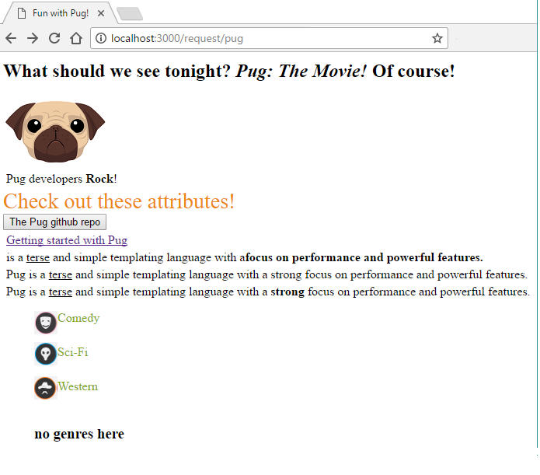

*<!--Created at Edge Tech Academy on 6/22/2017.  
Pug syntax styles - this one right here is a multi-line comment  
-->  
<!-- MIXINs are macros/functions to be used usually in iterating over a list-->*<!DOCTYPE **html**>  
<**html**>  
<**head**>  
 <**title**>Fun with Pug!</**title**>  
 <**link rel="stylesheet" href="/stylesheets/pug.css"**>  
</**head**>  
<**style**>  
 **p**.**genre** {  
 **color**: **#86aa16**;  
 }  
</**style**>  
  
</**html**>  
<**script type="text/javascript"**>  
 **var *findArea*** = **true**;  
 **if** (***findArea***)  
 *area*(5);  
  
 **function** *area*(radius) {  
 ***console***.log(**"The Circle has an area of: "** + **Math**.**PI** * **Math**.pow(radius, 2));  
 }  
</**script**>  
  
<**body**>  
<**h2**>What should we see tonight? <**em**>Pug: The Movie!</**em**> Of course!</**h2**>  
<**img src="/images/pug.png" class="imgClass"**>  
<**div id="container" class="signedIn"**>  
 <**p**>Pug developers <**strong**>Rock</**strong**>!</**p**>  
</**div**>  
*<!-- attrs is JSON, Pug will unwind it and use the key:value pairs as attributes-->*<**div id="foo" custom-attrib="EdgeTech" class="Registered" style="color**:**#ED8810**; **font-size**:28**px"**>Check out these attributes!</**div**>  
*<!-- Creating links, one with a button the other just a link-->*<**a href="https://github.com/pugjs/pug"**><**button**>The Pug github repo</**button**></**a**>  
<**p**>  
<**a href="https://pugjs.org/api/getting-started.html"**>Getting started with Pug</**a**>  
</**p**>  
*<!-- these next 3 paragraphs show how Pug interprets or doesn't interpret key works-->*<**p**>  
 <**Pug**>is a <**u**>terse</**u**> and simple templating language with a</**Pug**><**strong**>focus on performance and powerful features.</**strong**></**p**>  
<**p**>Pug is a <**u**>terse</**u**> and simple templating language with a strong focus on performance and powerful features.</**p**>  
<**p**> Pug is a <**u**>terse</**u**> and simple templating language with a <**strong**>strong</**strong**> focus on performance and powerful features.</**p**>  
*<!-- create a div with class=genreDiv, followed by a ul list-->*<**ul class="firstClass highClass noClass"**>  
 <**div class="Comedy imgAttr"**></**div**>  
 <**p class="genre"**>Comedy</**p**><**br**/>  
 <**div class="Sci-Fi imgAttr"**></**div**>  
 <**p class="genre"**>Sci-Fi</**p**><**br**/>  
 <**div class="Western imgAttr"**></**div**>  
 <**p class="genre"**>Western</**p**><**br**/></**ul**>  
<**ul class="genreList"**>  
 <**h3**>no genres here</**h3**></**ul**>  
</**body**>